**Distinguished Alumni of PTVAs M. L. Dahanukar College of Commerce**

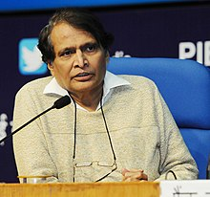

1. Shri. Suresh Prabhakar Prabhu (born 11 July 1953) is an Indian politician and currently serving as the [Minister of Commerce & Industry](https://en.wikipedia.org/wiki/Ministry_of_Commerce_and_Industry_(India)) and [Civil Aviation](https://en.wikipedia.org/wiki/Ministry_of_Civil_Aviation_(India)) under the [Modi government](https://en.wikipedia.org/wiki/Modi_government" \o "Modi government). He is a [Chartered Accountant](https://en.wikipedia.org/wiki/Chartered_Accountant) by profession and a member of the [Institute of Chartered Accountants of India](https://en.wikipedia.org/wiki/Institute_of_Chartered_Accountants_of_India) (ICAI). Since 1996, Prabhu has been a repeatedly elected Member of Parliament from [Rajapur Lok Sabha constituency](https://en.wikipedia.org/wiki/Rajapur_(Lok_Sabha_Constituency)" \o "Rajapur (Lok Sabha Constituency)) in [Maharashtra](https://en.wikipedia.org/wiki/Maharashtra) as a member of the [Shiv Sena](https://en.wikipedia.org/wiki/Shiv_Sena) (SS) political party. He quit Shiv Sena and joined [BJP](https://en.wikipedia.org/wiki/Bharatiya_Janata_Party) on 9 November 2014. He currently represents [Andhra Pradesh](https://en.wikipedia.org/wiki/Andhra_Pradesh) in the [Rajya Sabha](https://en.wikipedia.org/wiki/Rajya_Sabha" \o "Rajya Sabha).

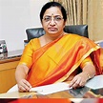**.**

1. **Smt. Vijayalakshmi Rajaram Iyer** serves as an Additional Independent Woman Director at Arihant Superstructures Ltd. since 2018. She is Non-Executive Independent Director of Jammu & Kashmir Bank Ltd since June 17, 2017. She has been an Independent Director at ICICI Securities Ltd. since November 29, 2017. She serves as Independent Director at Aditya Birla Finance Limited since October 26, 2017. She served as the Managing Director of Bank of India Limited since November 5, 2012 until May 31, 2015. Ms. Iyer served as the Managing Director of BOI, AXA Investment Managers Private Limited until May 31, 2015. She served as General Manager and Deputy General Manager of Union Bank of India.

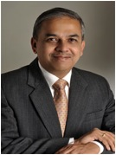

1. **Dr. Abhijit Phadnis** worked as the Chief Operating Officer of UBS Investment Bank in India and as Head – Finance, Operations and Administration with Credit Issues. He also served on the board of a leading co-operative bank. Dr. Abhijit’s academic record is quite exemplary in the accounting & finance domain with high ranks in all the professional examinations such as CWA (1983), CA (1984), CS (1987) and CFA (1989). His all-India ranks were 2nd, 11th, 1st and 3rd respectively. He was recently awarded a PhD by IIT Bombay for his pioneering work on ‘Factors influencing investments into Indian states.’ He has in the past served on the Academic Council and Board of Governors of the Institute of Chartered Financial Analysts of India.

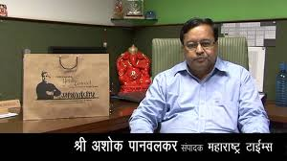

**4. Shri Ashok Panvalkar** is the Executive Editor of Maharashtra Times. Since 2008, Ashok Panvalkar took charge as editor of Maharashtra Times, a leading Marathi newspaper. Ashok Panvalkar joined Maharashtra Times in 1983 under the leadership of Govindrao Talwalkar. He is instrumental in Changing the content and layout of the paper.

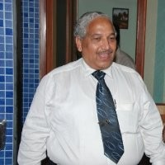

1. **Solicitor Shri. Vinay Jog** is Vice President of Parle Tilak Vidyalaya Association and one of the founder members of Alumni Association. He has drafted Bye-Laws of the Alumni Association. Practicing exclusively in Real Estate Documentation for last more than 15 years, creating/vetting documents on behalf of Builders/Sellers/Co-operative Housing Societies alike! Handled a number of FDI transactions right from the stage of drafting and finalising Term Sheets, Share Holders' Agreements, Share Subscription Agreements, Debenture Trust Deeds etc.

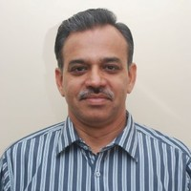

1. **Shri Ravindra Sathe** is an executive Director at Rambhau Mhalgi Prabodhini, a charitable organisation. The Probodhini is an academy for the training and orientation of Socio-political activists and a centre for overall public awakening activities and research projects.

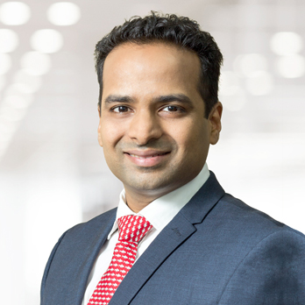

1. **Shri. Swanand Kelkar** is a portfolio advisor and analyst on the Global Emerging Markets team, focusing on India, and is based in Mumbai. He joined Morgan Stanley in 2007 and has 14 years of investment experience. He is an MBA from the Indian Institute of Management, Ahmedabad. He is also an associate member of the Institute of Chartered Accountants of India.

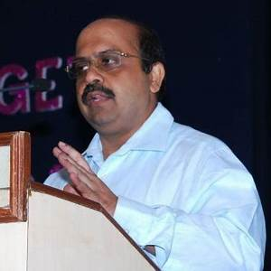

1. **CA Shri Santosh Kelkar** has been the director of Janakalyan Sahakari Bank Ltd. for the past 12 years and recently elected as Vice chairman. He has been practicing CA since 1996 after specialising in Consultancy in Direct and Indirect taxation and audit of all types of Assets including Banking sector. He was elected as Direct General Secretary of Bhartiya Janata party(North Central Mumbai) holding many responsible posts in BJP

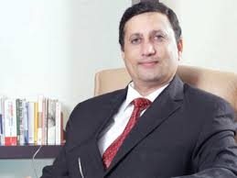

1. **Shri. Shashank Paranjape** serves as Managing Director of Paranjape Schemes (Construction) Ltd. and has been its Director since 1987.

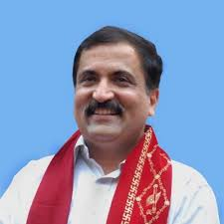

1. Shri. Atul Bhatkhalkar played a potent role in formulating strategies in ongoing groundwork for his party throughout Maharashtra. People know him as a leader that has had concerns for environmental and socio-philanthropic activities. He has worked in the economy’s liberalization policies globally, which resulted in significant changes in the field and is visible through the number of articles he has written to create awareness. .

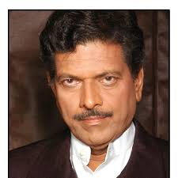

1. **Shri Ratnakar Tardalkar** has done dubbing in more than 1500 advertisements. His unique voice has been used in many programmes.



1. **Smt. Jyoti Parag Alavani** is a BMC Corporator from K – East Ward. She is an active member of Bhartiya stree shakti. She has actively participated in campaign to mobilise opinion in favour of 50% reservation of woman in politics, attanded and adressed meetings , seminars and even participated in the morcha on lokshabha.

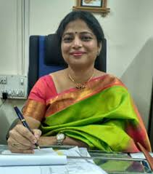

#### Dr. Vijetha Shetty, FDP (IIM,INDORE) is working as the Principal of Vivek College, Mumbai. She has been felicitated with Social Action Award by Indian Development Foundation (IDF).

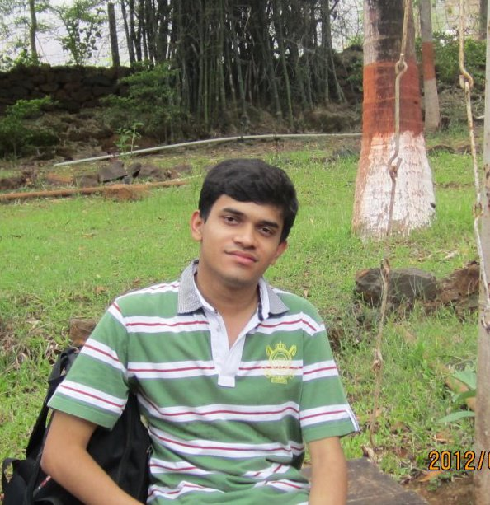

1. **Shri. Mayuresh Dharap** has secured ALL INDIA RANK 4 in CA final examination, All India Rank 6 in CS Executive Programme (New) December 2013, FIRST Position at TYBCOM in Mumbai University with 95.86% Aggregate Marks, ALL INDIA RANK 1 in CMA Foundation December 2010.

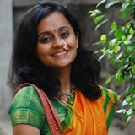

1. **Smt. Mruga Ghanvatkar Paranjape**, currently working as the Manager at RBI. She has done online certification on financial planning and policies, part 1, Economics, 85%. Master in Business Education from NMIMS, Masters in Commerce, Accountancy, M. L. Dahanukar College of Commerce. She was the topper at University of Mumbai.

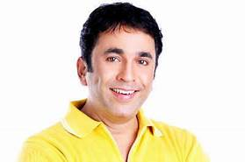

1. **Shri Pushkar Sudhakar Shrotri** is a [Marathi](https://en.wikipedia.org/wiki/Marathi_people), Hindi film & theatre actor, producer and director. He has also given direction in few plays and the recent Marathi film [Ubuntu](https://en.wikipedia.org/wiki/Ubuntu_(film))

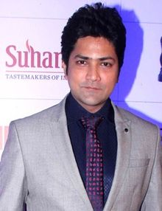

1. **Shri Aniket Vishwasrao** is an Indian film actor. He is best known for his work in [Marathi cinema](https://en.wikipedia.org/wiki/Marathi_cinema).

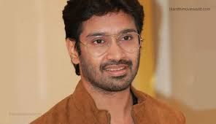

1. **Shri Nilesh Moharir** is an Indian music director. He composed several songs in [Marathi](https://en.wikipedia.org/wiki/Marathi_language). He has composed around 46 title tracks,15 non-film music albums and 8 movies in [Marathi](https://en.wikipedia.org/wiki/Marathi_language). He is known for his catchy melodious music.

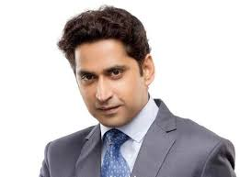

1. **Shri Chinmay Mandlekar** is an Indian actor, writer and stage director, mostly active in the Marathi entertainment industry.

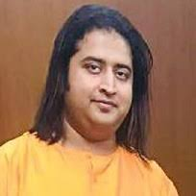

1. **Swaradhish Dr.Bharat Mohan Balvalli** is an accomplished singer and music composer, who has released multiple albums and has gained recognition in Indian music industry at a young age. He has taken training under various accomplished Gurus for classical singing and harmonium. His album on Swatantryaveer Vinayak Damodar Savarkar was inaugurated by Honourable Prime Minister of India, Shri Narendra Damodardas Modi in 2014.

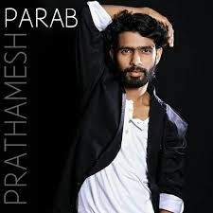

1. **Shri Prathamesh Parab** (born 29 November 1993) is an Indian actor who works in Marathi cinema. He played a small role in Balak Palak before playing a lead character in Timepass. He reprised his role in its sequel Timepass 2 as a younger version of his own character. He has also worked in hindi movie Drishyam with Ajay Devgan and Tabu. He received the Star Studded Annual Life Ok Screen Awards for (2014).

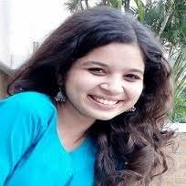

1. Bhagyashree Shankpal is an Indian actress. She is best known for his work in [Marathi cinema](https://en.wikipedia.org/wiki/Marathi_cinema).

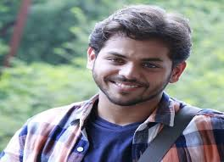

1. Yashoman Apte is an Indian actor and has won Inter University youth festival National level overall championship runners up trophy. He has also won 5 individual trophies in Mumbai University youth festival at state level competition. He is best known in Marathi Cinema.

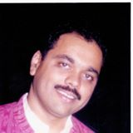

1. Principal at Abhinav College of Arts, Commerce & Science-Bhayander.  Studied at M L Dahanukar College of Commerce, Mumbai... He is Surveyor General at  **Paranjape** Schemes (Construction) Ltd.